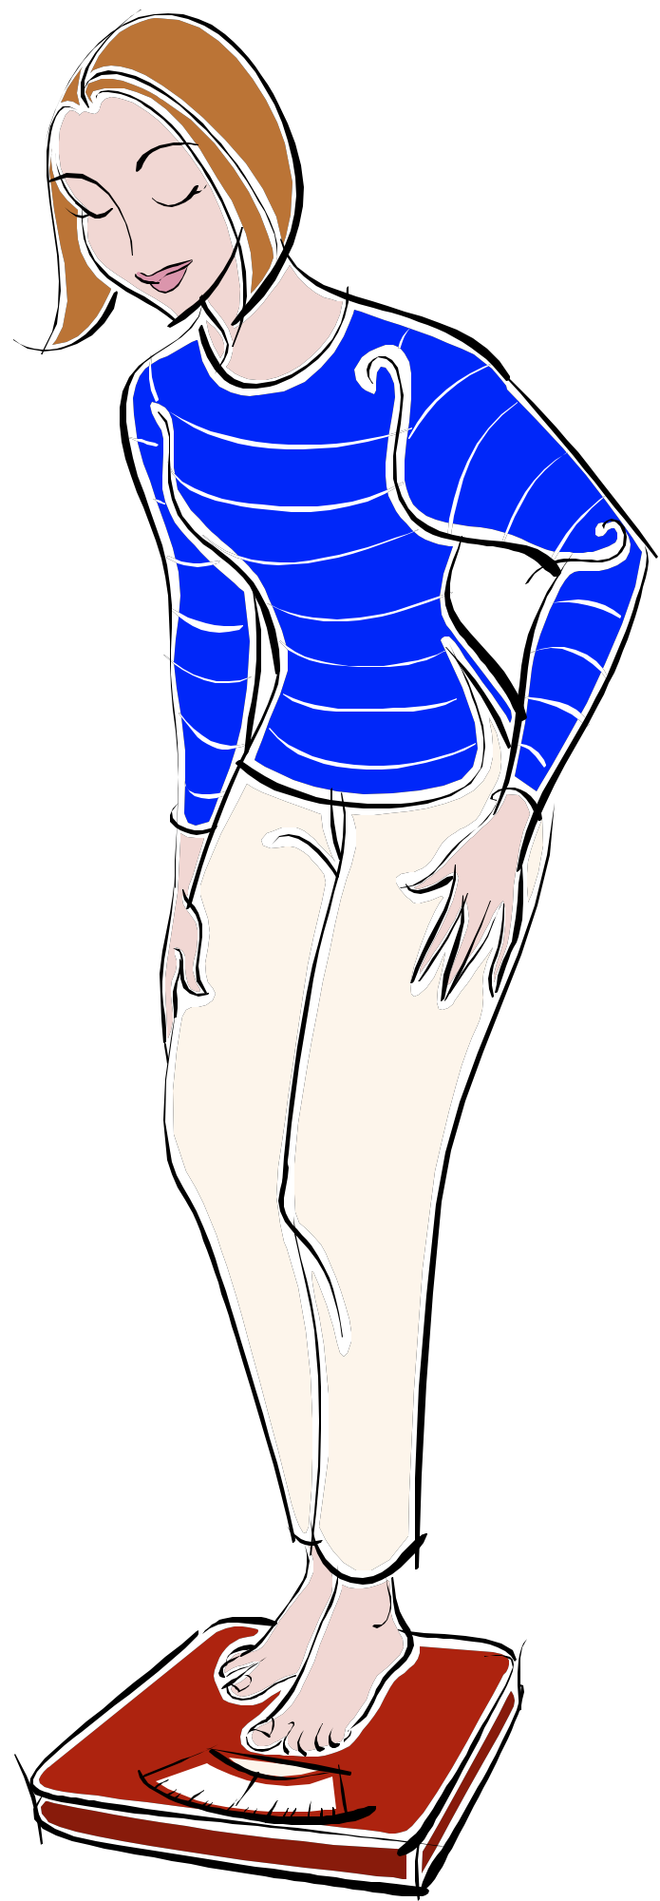Overview of Lesson:
Fad Diets- part 1
- Lesson preview/ warm up activity
- Review of previous topics
- You tube clip – Part 1
- Discussion on fad diets – what they are, why are they bad
- Activity – before and after diets
- You tube clip – Part 2
- Conclusion

Year level:  Year 9  Level 6 VELS | Topic:  Fad Diets (Part 1)  (with a review of previous topics: nutrition, exercise and obesity.) | Resources:  - Teachers notes.  - You tube clips:  - http://www.youtube.com/watch?v=zlcDDHSU7ns&feature=relmfu  - http://www.youtube.com/watch?v=tUK8OakVWvE&feature=relmfu  Equipment:  - Data projector.  - Laptop.  - A collection of women’s magazines.
AusVELS Focus:  (See Curriculum tab) | Lesson Duration:  2 Periods (100 minutes) | Learning Intentions:  - To revisit previous topics – Nutrition, exercise and obesity.  - To introduce students to fad diets..  - To equip students with the skills to evaluate diet claims.  - To enable students to makes sensible dieting choices.
Links to students prior knowledge and experiences:  At year 9 level it is expected that students have at least a basic knowledge about fad diets, if they haven’t tried them themselves they may have family who have. |  | Assessment/ feedback strategies.  - Class discussions and student input.  - Walking around the class to gauge student participation.  - Asking questions of students who do not seem engaged.
Room set up: |  | - Students tables and chairs facing the board.  - White board and markers.  - Learning intentions and todays activities written on board.  - Data projector and laptop set up and ready.
Lesson Sequence: |  | What do I expect to see students doing to indicate thinking and learning? | Time
Phase 1: Engaging the learner:  - As a class discuss and list on board ideas of what a diet is and any good or bad aspects of dieting.  - Ask students how these link to the nutrition and obesity class?  - Talk about the students will learn in this topic. |  | - Students contributing to the discussion and offering ideas.  - Students showing evidence of previous health topics. | 10 min.
Phase 2: Exploring:  - Introduce the 3 Youtube clips the students will be viewing during this topic and why.  - Show first clip.  - http://www.youtube.com/watch?v=zlcDDHSU7ns&feature=relmfu  - Write set of questions on board.  - What size does Michelle currently wear  - What condition does the doctor say Michelle’s body is in?  - What dangers does the doctor warn Michelle about?  - What size does Michelle want to get down to?  - How long will it take?  - Discuss the questions. |  | - Students will be paying attention to the Youtube clip and taking notes.  - This series of clips follows the journey of a British journalist as she tries to lose 2 dress sizes (from a size 10 to a 6) over a period of 2 weeks. | 15 min.
Phase 3: Explain:  Teacher presentation:  - Fad diets are those which promise quick weight loss over a short period of time.  - often endorse expensive creams or supplements.  - are not based on a nutritionally balanced diet.  - claim they are suitable for everyone, regardless of age or sex.  - target people who are vulnerable  - Research shows us that the best results for permanent weight loss is to eat a nutritionally balanced diet and exercise.  - Fad diets such as 'The grapefruit diet' and the 'Hollywood 48 hour miracle diet' promise much and deliver little. (Prompt students to suggest others).  - Body stores extra fat as it believes that it is being starved, weight loss is a loss of water not fat.  - It is believed that fad diets make the body’s metabolism slow down even more to conserve energy which results in greater weight gain when a normal diet is resumed. |  | - Students will be taking notes and asking questions to clarify their understanding. | 15 min.
- Fad diets are dangerous because:
  - they limit certain food groups.
  - do not contain a balance of nutrients.
  - do not provide enough kilojoules to meet the bodies daily needs.
  - do not encourage enough physical activity.
  - do not plan for weight loss over a long period of time.
  - does not address behavioural problems.
Phase 4: Elaborate:  Introduce activity:  Students (in teams) are to collect before and after photos of celebrities who have been on a fad diet.  - Are they on another diet?  - Why are they on a diet?  - Do they want to lose weight for health reasons or because of society’s expectations?  - Do they look better before or after the diet?  - Are they healthier before or after the diet? |  | - Students will be making posters using women’s magazines.  - This activity will reinforce the idea that movie and music stars are constantly under pressure to lose weight even though they may be in the healthy range.  - This activity will show that losing weight does not necessarily lead to body perfection. | 30 min.
Phase 3: Explore:  Class discussion on what the students found out during the activity. List on board.  Play second Youtube clip:  http://www.youtube.com/watch?v=tUK8OakVWvE&feature=relmfu  Questions on board:  - What is Michelle's food plan for the next two weeks?  - What will be her average calorie intake? What should she be taking in?  - How is the maple syrup diet dangerous?  - What are the mental dangers associated with extreme diets?  - What are the emotional/mental effects Michelle is experiencing? |  | - Students would participate in the discussion. They would offer their findings and listen to other student’s findings. | 15 min.
Conclusion:  Reiterate important parts of this class.  Inform students of plans for next class – being an assessment task. |  | - Students listening and making any final notes. | 5 min

