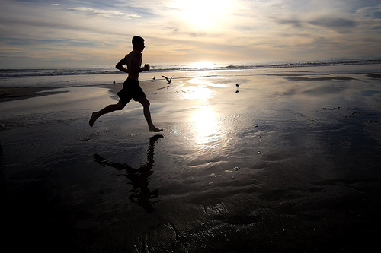

Exercise (physical activity)

Example of a case study that would have been pre-prepare on the whiteboard:

Suzie is 15 years old; she enjoys netball and hanging out with their friends. Susie rides her bike to and from school each day; it takes her 15 minutes to get to and from school, altogether 30 min each day. Today is Wednesday and Suzie has physical education class, in a class they will be doing swimming. But Suzie didn’t know this and she didn’t bring her swimming gear, so she was unable to participate in today’s physical education classes. After Suzie finishes school and arrives home, she gets ready to go to netball training (netball training goes of 45minutes).

Is Suzie meeting the daily-recommended requirements of an adolescent her age?

Yes or no? And why

Through class discussion, the students should come to the conclusion that Suzie is meeting her daily-recommended requirements for an adolescent her age.
Suzie is completing 115mins of moderate to vigorous physical activity, which is 15minutes more than the recommended daily requirement. Even though she wasn’t able to participate in her physical education class. She Achieved the daily-recommended requirements by riding to school, which takes 30 minutes, and going to netball training, which is another 45 minutes.

