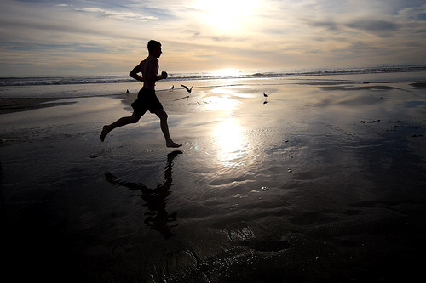

Exercise (Physical Activity)
Name__________

Evaluating your own personal exercise (physical activity) homework, referring to the recommended daily requirements:

Here are some questions in which you will fill out the frequency, intensity, time and type of exercise that you completed on one day during the week. To be completed before the next class.

Frequency (how many times a day):

………………………………………………………………………………………………………………………………………………………………………………………………………………………………………………………………………………………………………………………………………………………………………

Intensity (moderate or vigorous):

………………………………………………………………………………………………………………………………………………………………………………………………………………………………………………………………………………………………………………………………………………………………………

Time (How Long):

………………………………………………………………………………………………………………………………………………………………………………………………………………………………………………………………………………………………………………………………………………………………………

Type (what type of exercise did you partake in):

………………………………………………………………………………………………………………………………………………………………………………………………………………………………………………………………………………………………………………………………………………………………………

